Battle of The

Neighbourhoods.

IBM Data Science Professional Certificate

Applied Data Science Capstone

Muthahar Nasim

# Introduction/business problem

* Our customer, the coffee shop chain “coffee-mugs” is interested in opening a new coffee shop in Toronto. Toronto is the fastest growing city in North America. It is an international centre of business, finance, arts, and culture, and is recognized as one of the most multicultural and cosmopolitan cities in the world. This would be our customer’s second location, after having successfully opened a venue in Adelaide, a very lively neighbourhood from Scarbrough.
* Considering that our customer has had very good results with their current location, they have requested our data science team to find a neighbourhood with similar characteristics.
* The problem question would be: What other neighbourhood from Toronto has the most similar characteristics in terms of entertainment and cafe options compared to Adelaide?

# Data Used

* Foursquare- It is a local search-and-discovery service which provides information on different types of entertainment, drinking and dining venues. Foursquare has an API that can be used to query their database and find information related to the venues, such as location, overall category, reviews, and tips.
* Toronto Neighbourhood Names and geographic coordinates- We will scrap a Wikipedia page for the postal codes of the Burroughs and the URL "https://cocl.us/Geospatial data" for the geographic coordinates of each borough

# Methedology

* Scraping the Wikipedia page to get the postal codes for each neighbourhood

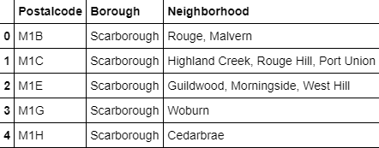

* Getting the geolocation of each neighbourhood

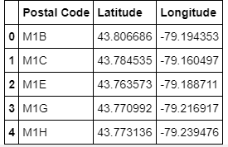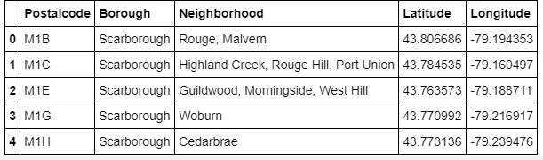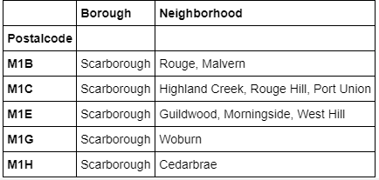

# Toronto Neighbourhoods

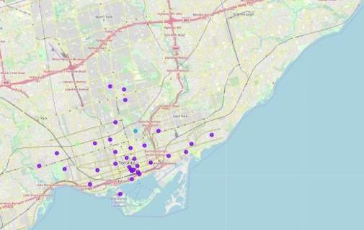

Foursquare API- Getting insights on each neighbourhood

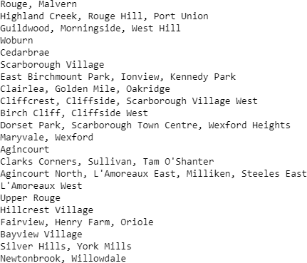

* Venue categories

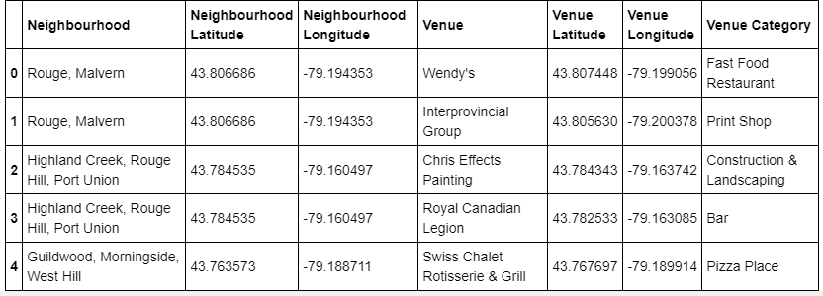

# Applying one-hot-coding

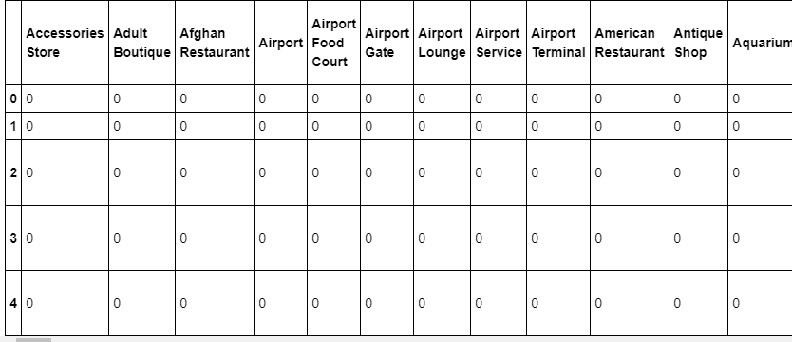

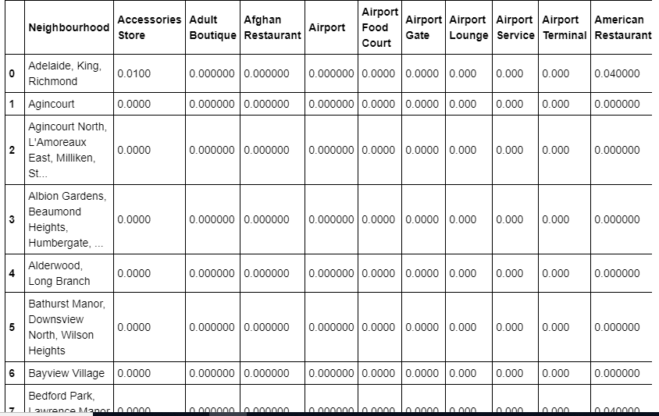

Getting the top five venues in each

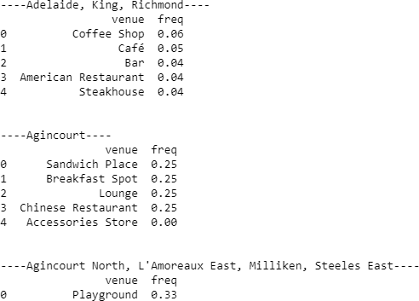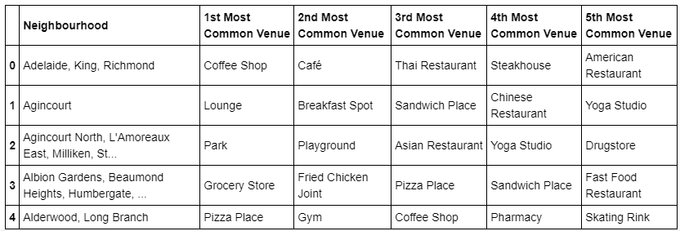

neighbourhood

Clustering the neighbourhoods

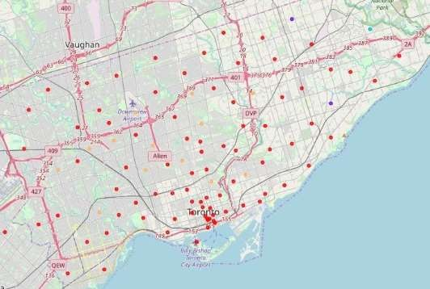

Result

* We observe that downtown Toronto and central torontoarethe best

location for a new branch for our customer “Cofee-mugs”

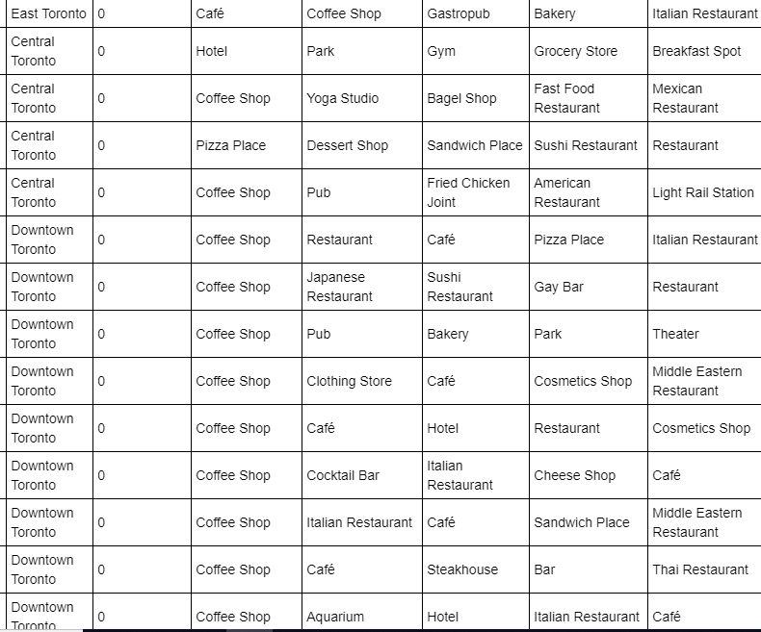

# Conclusion

* + Our location, Adelaide lies in the cluster number 0.
  + We observe that downtown Toronto and central Toronto have successful caffe buisnesses just like our neighbourhood Adelaide.